# **I'm Totally a Monica**

### How much stock should we actually put in personality tests?

Zoe's avatar

[Zoe](https://substack.com/@zoeffc)

Oct 25, 2024

Share

Hiya!

As many of you know, I am my friends’ go-to astrology girl. I am the one that gets asked if you and your crush are compatible or if Mercury is in retrograde again. If I ever ask you for your birthday, know that it’s not just for my type-a calendaring tendencies. My fascination doesn’t stop with astrology, though. I love the idea of being able to pin down “types” of people. I was totally obsessed with the “tag yourself” memes in high school and still think about my aesthetic genre on a daily basis.

Me? I am an Aries sun, Aries moon, Taurus rising, INFJ, and an Enneagram 8.

Today, I want to explore the ways that the corporate world may also have astrology girl tendencies.

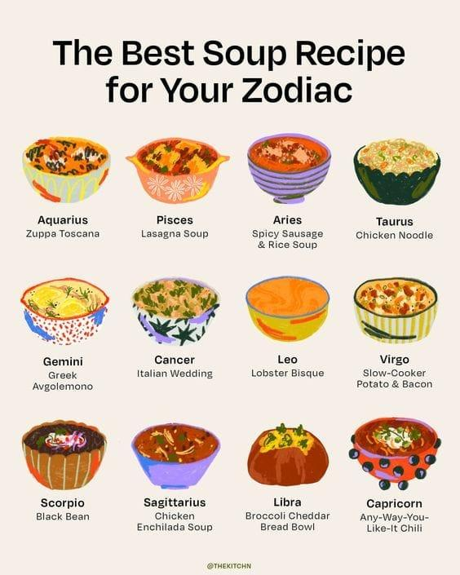

First some housekeeping:

📫 If a friend forwarded you this newsletter (then you have some really cool friends), and you may want to consider joining us here for regular updates.

[Subscribe](https://femme-futures.beehiiv.com/subscribe)

🧲 Got some thoughts you want to share? Join us on Discord to chat all things newsletter and corporate life.

[Discord](https://discord.gg/N84WxemQ?utm_source=femme-futures.beehiiv.com&utm_medium=referral&utm_campaign=i-m-totally-a-monica)

You can find all archived newsletters at the online site, if you ever want to go back or if you just feel like perusing.

[Check out the website](https://femme-futures.beehiiv.com/)

I took the Clifton Strengths Assessment as I left my first job. At this point in my life, I was 23, insecure about my abilities, and terrified of what my future might hold. I had left a toxic work environment where my confidence was totally decimated. A friend from that job pushed me to take this assessment because she could see my value and wanted to give me a concrete way for me to see it.

For those who are unfamiliar with the Clifton Strengths Assessment, it is a pretty standard corporate personality test. It gives you a list of your top five professional strengths. At the time, my five were: Individualization, Arranger, Activator, Command, and Intellection. As it would turn out, those traits are aligned with that of the INFJ, the Aries, and the Enneagram 8. So what I want to know is why in the professional world we are more comfortable with using certain classifications than others.

Let me make my personal stance clear: I think it is interesting how these personality tests can allow us to make educated guesses about people, BUT I do not believe that they define the individual person. In fact, I have met many people who’s personalities do not align with what the personality test would indicate. (I am looking at my Sagittarius sister on this one.)

People seek to understand other people, especially when those people are important in their lives. Just yesterday, I was listening to a podcast from NYT Opinion Columnist, Ezra Klein, where he dissected Donald Trump’s personality through a lens of five key personality pillars. It was fascinating. Brené Brown has a values assessment that she encourages the organizations that she works with to take. We crave understanding ourselves, our teams, our communities, and our society.

I see the primary benefit of personality tests to be encouraging introspection. When I look at the Clifton Strengths results that I received, I cringe a little bit, but I also feel a sense of pride. I mean, what kind of 23-year-old emanates command? And if they do, are we sure it’s not something else masquerading as “command”? On the other hand, the skill of individuation is something that I am personally very proud of. It means that I take time to understand the people that I work with and how to best communicate with and work with them. Likewise, as an 8 and an Aries, I am aware of my gravitational pull toward confrontation — and I am able to take a beat and check that instinct. It starts with self-knowledge.

Now, is it helpful to know other people’s various personality descriptors? I know that I am always curious about it. I looked up my boyfriend’s Meyers Briggs type the other day and am absolutely seeing some ways that it really fits him. On the other hand, I am afraid of the reductionist impulse that comes along with these tests. That’s the hazard with creating boxes for people, we each personally need to be aware of when we are doing that and be ready to be surprised by the real person in front of us.

There was someone in my life that I really struggled with because I felt like she was incapable of exercising empathy. Let me tell you what a surprise it was to discover that her top Clifton Strength was empathy (and she shares a zodiac sign with my Dad, one of my favorite people). The tests reflect how you see yourself, not necessarily how other people might see you. From that perspective, better understanding how people see themselves could be incredibly helpful, especially as you navigate teams.

It is interesting how some personality tests are taken more seriously than others. Those Buzzfeed tests that told you what kind of ice cream you are were fun to share with your friends, but hardly became a personality trait. But it’s a different story if you ask someone what their Hogwarts House is (Ravenclaw), or which character from F.R.I.E.N.D.S. they identify with (Monica). Some people put a lot of stock into astrology, while others brush it off with the same ease that they might brush off a Sex in the City personality quiz. Some people brush off Clifton Strengths or Meyers Briggs, while others encourage institutional investment in them.

The question I want to leave you with is this: how different are corporate personality indicators from pseudo-science?

So tell me, which F.R.I.E.N.D.S. character do you identify with?

Zoe

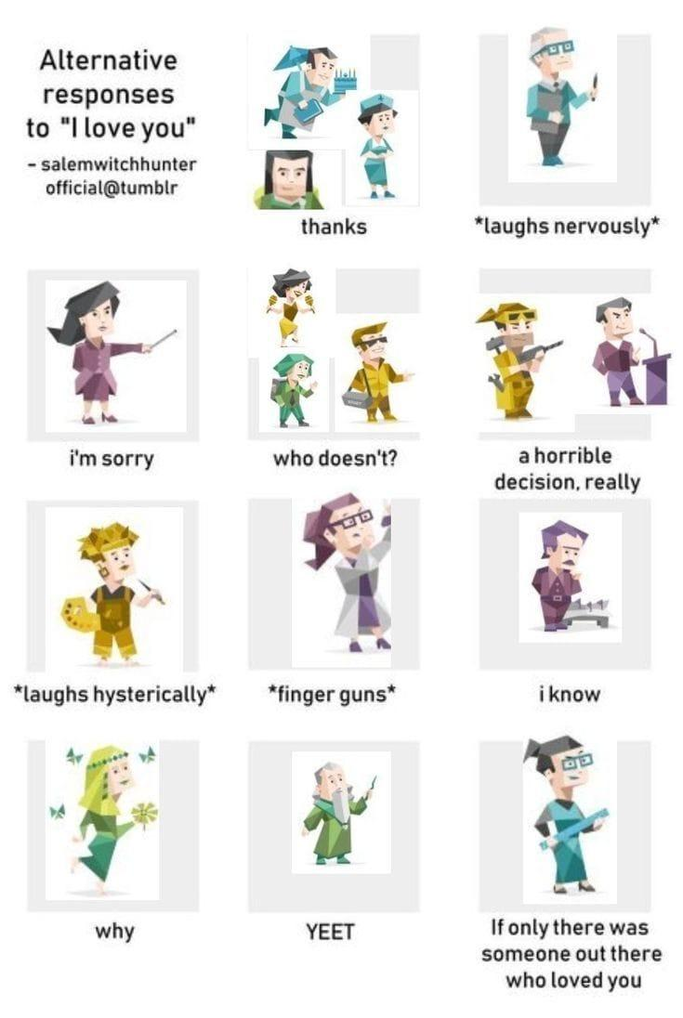

**Femme Futures Cooperative Founding Principles**

💚 **Mission**: The mission of Femme Futures is to create a community space for young professionals who identify as over-achievers and activists to generate collective success by providing resources and platforms to thrive in challenging workplace environments.

💙 **Vision**: To contribute to a world where driven individuals are equipped with the tools, guidance, and connections to overcome systemic barriers, fully utilize their talents, and enact positive change in their organizations and communities.